The new Varioline ironing table series

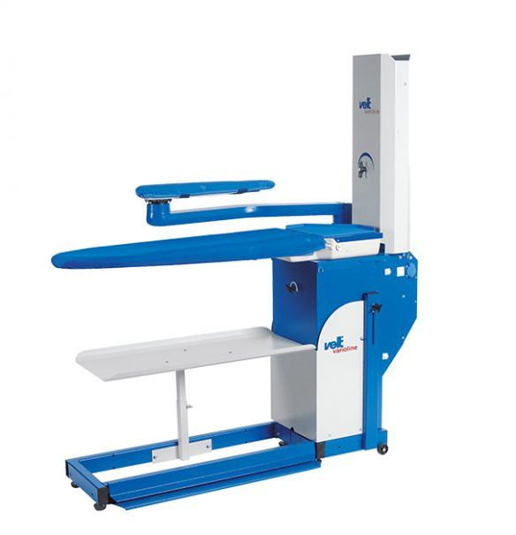
The new Varioline ironing table series excels with its outstanding suction or suctions and blowing power at a low noise level. The automatic switch-over from suction or blowing on the ironing surface to the swivel arm works mechanically.
The adjustment of suction and blowing power is done mechanically by flap as well. The comfortable height adjustment is supported by a gas spring. Its wide range of adjustment (830-990mm) allows perfect individual adjustment to the operator.
Available as suction only or suction and blowing version.
For your individual needs we offer a wide variety of accessories from our building block system.

Advantages
- The comfortable height adjustment supported by a gas spring with its impressive adjusting range (830-990mm / 32.7-39.0 inch) provides for an optimal adaption to the operator
- The flap box made of high quality plastic provides for outstanding power at a low noise level

